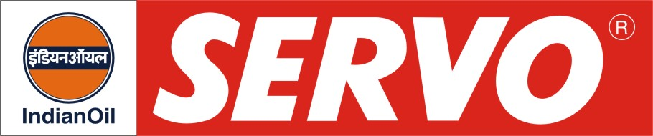
GRADES AVAILABLE - SERVO PRIDE XL 15W-40
DESCRIPTION

Servo Pride XL 15W-40 is API certified, premium commercial multipurpose diesel engine oil. The oil is designed for the most severe performance requirements of new generation diesel engines for on and off highway operations. It assures outstanding protection against high temperature engine deposits, oil degradation, oil thickening and corrosion resistance. The oil is having excellent shear stability to maintain viscosity under severe, high temperature operations. It exhibits outstanding control on soot induced thickening and soot induced wear.

APPLICATION

Servo Pride XL 15W-40 is recommended for new generation commercial diesel vehicles of both American and European design such as Caterpillar and Cummins operating on Heavy duty on-highway and off-highway equipments. It is tailored to the lubrication requirements of engines complying to EURO III. It is especially compounded for use with diesel fuel ranging in sulphur content upto 0.5% by wt.

PERFORMANCE STANDARDS

* API CH-4
* MB 228.3
* MACK EO-M Plus
* MAN 3275
* VOLVO VDS-2
* Cummins CES 20076
* ACEA E3-96

PERFORMANCE BENEFITS
# Reduced engine scuffing and bore polishing.
# High engine cleanliness.
# Maximum protection from wear and deposits.
# Suitable for mixed fleet operation.
# Improved control of oil consumption.
# Easier cold starting.
# Excellent all weather performance due to improved cold weather properties.
# Has the potential to doubled the oil drain
intervals compared to current diesel engine
oils.
compared to current diesel engine oils
period.

CHARACTERISTICS

SAE GRADE | 15W-40
Kinematic Viscosity, cSt @ 100°C | 13.5 – 15.5
Viscosity Index, Min. | 135
TBN, mg KOH/g | 10.0 – 11.5
Flash Point, (COC)°C, Min. | 200
Pour Point °C, Max. | (-) 24

