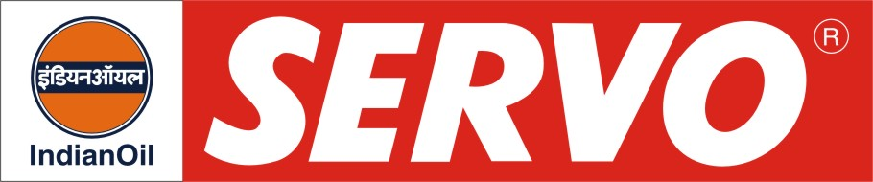
Special Purpose Hydraulic Oils (Anti-wear Type)

PRODUCT | Kin. Viscosity cSt at 40 °C | VI Min. | Flash Point COC, °C Min. | Description / Application
Servosystem HLP 10  Servosystem HLP 22  Servosystem HLP 32  Servosystem HLP 46  Servosystem HLP 68  Servosystem HLP 100  Servosystem HLP 150 | 9 - 11  20 – 24  29 – 35  42 – 50  62 – 74  90 – 110  135 – 165 | 100  100  100  98  95  95  90 | 125  165  200  204  210  210  230 | Servosystem HLP oils are premium hydraulic oils having high FZG rating. This oil meets DIN 51524 Part 2 Denison HF-O US Steel 127, Cincinnati Machines P-69 and P-70 and also IS: 10522-1983 (Reaffirmed 2004) and IS: 11656-1986 specifications. Servosystem HLP oils are recommended for high performance electro-hydraulic or numerically controlled systems. These oils are extensively used as screw compressor oils also.
Servosystem HLP 22 AF  Servosystem HLP 32 AF  Servosystem HLP 46 AF  Servosystem HLP 68 AF  Servosystem HLP 100 AF  Servosystem HLP 150 AF | 20 – 24  29 – 35  42 – 50  62 – 74  90 – 110  135 - 165 | 100  100  98  95  95  90 | 165  200  204  210  210  230 | Servosystem HLP AF Oils are ash less type high anti-wear hydraulic oils meeting performance requirements of DIN 51524 Part 2, Cincinnati Machines P-68, 69 & 70 and IS:10522 and IS 11656 specifications. They possess superior demulsibility thermal and oxidation stability and excellent filterability, essentially required for the equipments working in humid environment.
Servosystem HLP 22 N  Servosystem HLP 32 N  Servosystem HLP 46 N  Servosystem HLP 68 N  Servosystem HLP 100 N | 20 – 24  29 – 35  42 – 50  62 – 74  90 – 110 | 95  95  95  95  90 | 165  200  204  210  210 | Servosystem HLP N oils meet the requirements of DIN 51524 HLP (Part 2) and Cincinnati Machines and Vickers Vane pump test requirements. These oils provide good film strength, anti-wear properties to minimise wear in pumps, rings, valves, pistons. These oils have high viscosity index to restrict any viscosity change under continuous operating conditions and resistance to foaming to ensure efficient functioning. Servosystem HLP N oils are recommended for use in hydraulic systems, compressors, pumps, circulation oiling systems, enclosed gearboxes etc.

